**Size-weight relationship of eastern Bering Sea commercial crab species**

Liz Chilton

Affiliation: NOAA/NMFS/RACE Kodiak

Address: 301 Research Court, Kodiak, AK 99615

E-mail: elizabeth.chilton@noaa.gov

**Project description:**

Carapace size-weight parameters of commercially important crab species fished in the eastern Bering Sea (EBS) have not been updated since the early 1980’s. This size-weight relationship is used in stock-recruitment models developed for Bristol Bay and Pribilof Islands red king crab (*Paralithodes camtschaticus)*, Pribilof Islands and St. Matthew blue king crab (*P. platypus*), and eastern Bering Sea tanner crab (*Chionoecetes bairdi*) and snow crab (*C. opilio*). The objective of this project is to provide updated size-weight parameters for males as well as ovigerous and non-ovigerous females.

**Methodology:**

Individual crab were weighed to the nearest gram and carapace length or width measurements were collected from male and female red king crab, blue king crab, tanner crab and snow crab caught on the 2006 through 2011 eastern Bering Sea bottom trawl survey. Shell condition was determined for all individual crab as well as clutch size, egg condition and egg color for ovigerous females. Carapace length measurements were collected from red and blue king crab and carapace width measurements from tanner and snow crab and recoded to the nearest 0.1 mm. Measurements were only collected from live, whole crab with all legs intact, individuals with missing or regenerated legs were not selected. Size-weight data was also collected on 2000 and 2001 EBS bottom surveys using the same methodology although the carapace size measurement was only recoded to the nearest whole 1 mm unit.

Data reported here are separated into male and female groups and females are divided into ovigerous and non-ovigerous females. The ovigerous female category refers to females brooding egg clutches, while non-ovigerous females are comprised of immature females (000), barren females (001) and females with empty egg cases (041).

The size-weight relationships are described by the expression: W = a Lb

where W is the total weight in grams, L is either carapace length (CL) or carapace width (CW) in mm, *a* is the intercept in log scale and *b* is the slope. Parameters *a* and *b* for the size-weight relationships are estimated from a linear regression fitted to log-transformed size-weight data1.

|  |  |  |  |  |
| --- | --- | --- | --- | --- |
| Species | Number | *a* | *b* | R2 |
| Red king crab males | 1607 | 0.000395 | 3.145108 | 0.98 |
| Ovigerous red king crab | 974 | 0.003785 | 2.652344 | 0.92 |
| Non-ovigerous RKC | 564 | 0.000694 | 3.013095 | 0.97 |
| Blue king crab males  Blue king crab females2  St Matthew males | 878  838 | 0.000387  0.02065  0.000385 | 3.157246  2.2700  3.157087 | 0.94  0.95 |
| Tanner crab males | 1956 | 0.000270 | 3.023106 | 0.99 |
| Ovigerous Tanner crab | 627 | 0.000554 | 2.848119 | 0.95 |
| Non-ovigerous Tanner | 1086 | 0.000531 | 2.834235 | 0.97 |
| Snow crab males | 2190 | 0.000241 | 3.119794 | 0.99 |
| Ovigerous snow crab | 1172 | 0.000807 | 2.796833 | 0.95 |
| Non-ovigerous snow crab  Hair crab males3  Hair crab females3 | 808  703  178 | 0.000920  0.00071731  0.00119453 | 2.738200  3.02  2.86 | 0.97  0.93  0.95 |

(1) Chilton, E.A. 2011. Size-weight relationships of commercial crab in the eastern Bering Sea.

(2) Alaska Fisheries Science Center, Kodiak Laboratory unpublished data.

Data source unknown, taken from original size-weight data sheet from Brad Stevens. Currently, we have 160 females measured (2000-2011): 62 non-ovigerous & 23 ovigerous in Pribs, 67 non-ovigerous & 8 ovigerous in St. Matts

(3) Armetta, T.M., and B.G. Stevens. 1987. Aspects of the biology of the hair crab, *Erimacrus isenbeckii*, in the eastern Bering Sea. Fishery Bulletin 85(3):523-545.

Figure 1. Monthly averaged water temperatures (°C ± SD) at the Bristol Bay mooring M2 in eastern Bering Sea from May 1997 to July 2010. Data in July 2009 was not available due to equipment failure.



Figure 2.The percentage of sea ice coverage in the eastern Bering Sea as the average ice concentration in a 2° x 2°box at 56-58°N, 163-165°W from 1972-2010. The numeric color scale on the right corresponds with the percentage of ice coverage (Source: Hunt et al. 2011).

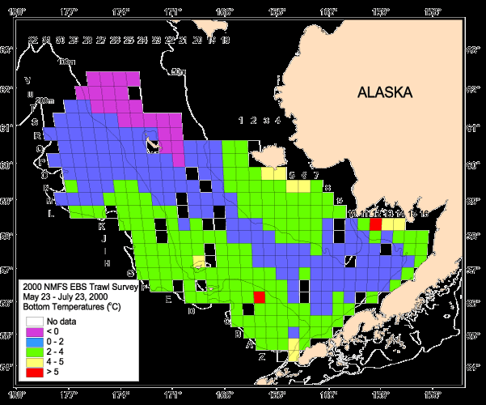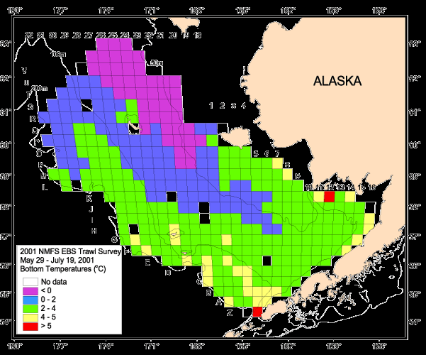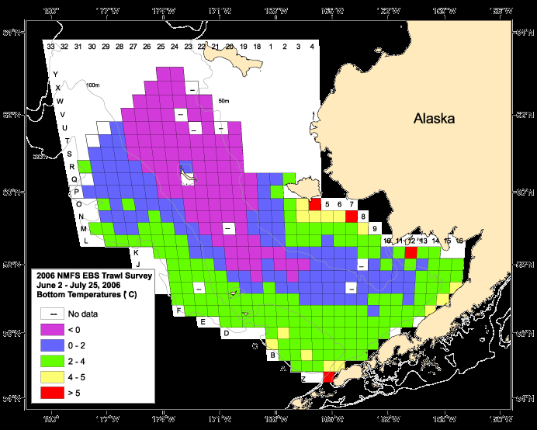GearTemperature_color 2007.tif

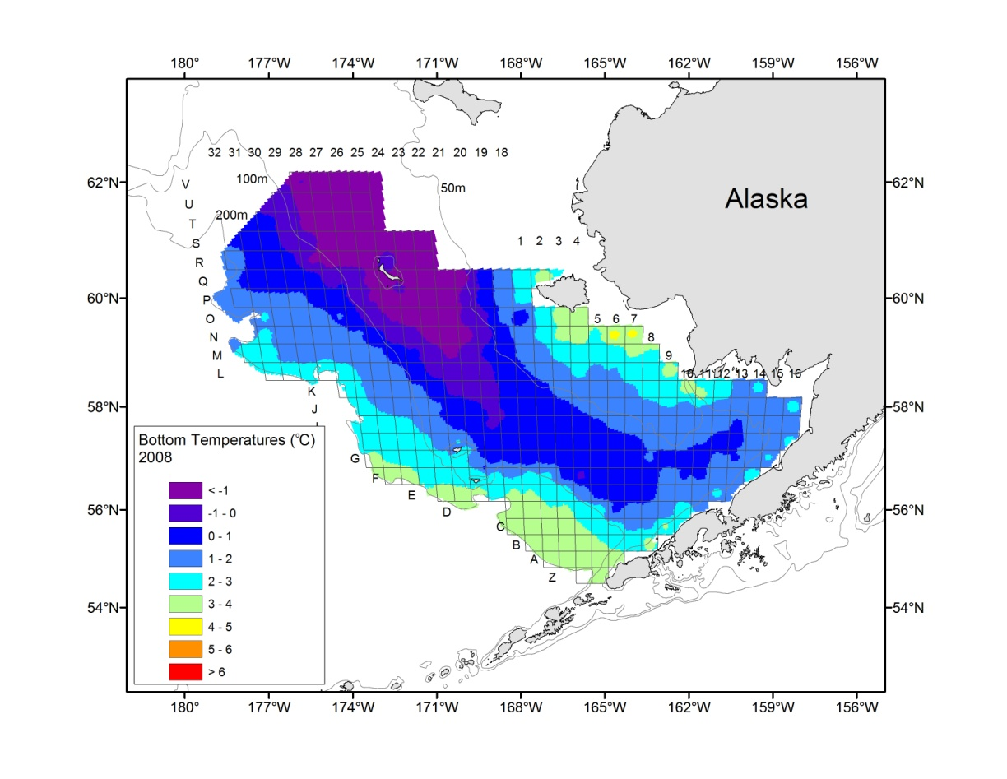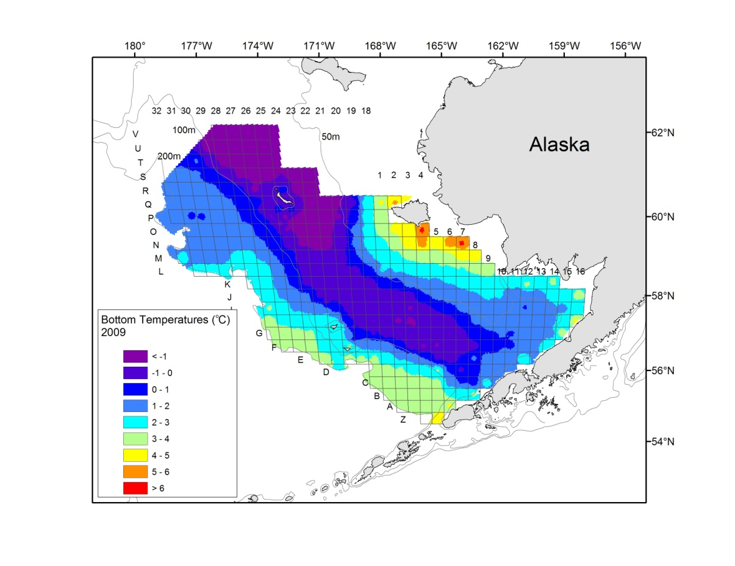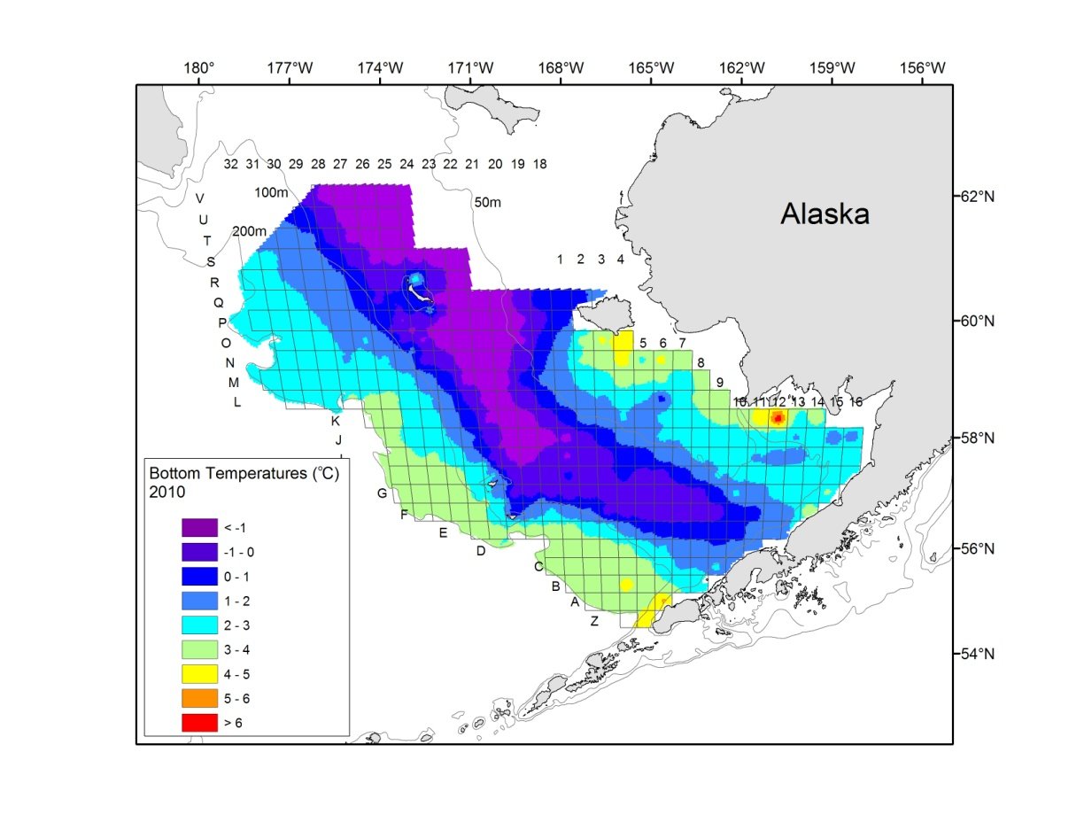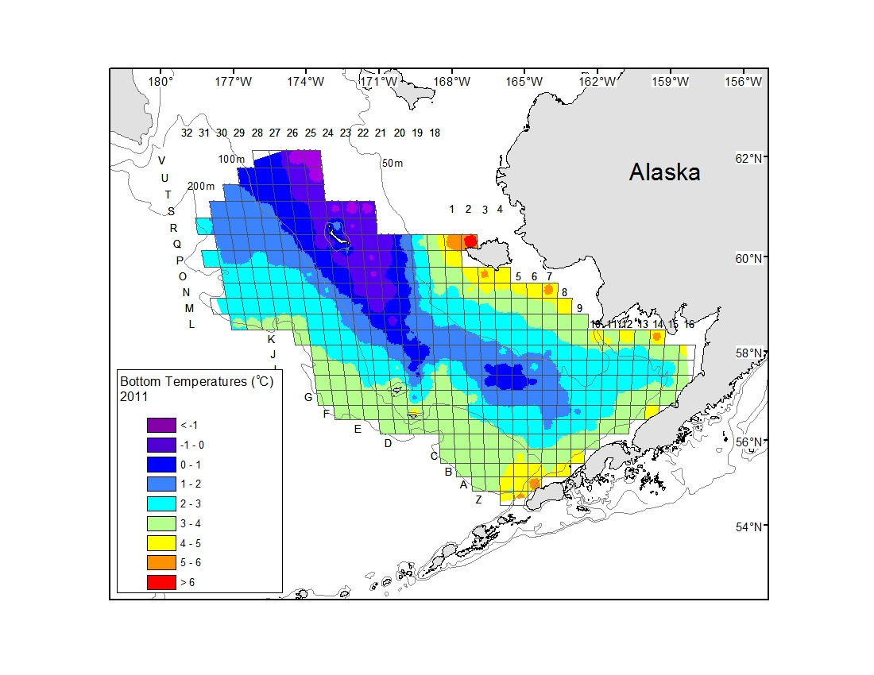

Figure 3. Mean bottom temperatures measured at stations from the annual National Marine Fisheries Service eastern Bering Sea bottom trawl survey; 2000, 2001, and 2006-2011.

|  |  |  |  |  |  |  |  |  |  |  |
| --- | --- | --- | --- | --- | --- | --- | --- | --- | --- | --- |
| 2000-2010 data set |  |  |  |  |  | Including 2011 data | |  |  |  |
| Species | Number | *a* | *b* | R2 |  | Number | % Contribution | *a* | *b* | R2 |
| Red king crab males | 1402 | 0.000407 | 3.138922 | 0.98 |  | 205 | 13 | 0.000395 | 3.14511 | no change |
| Ovigerous red king crab | 897 | 0.003868 | 2.647933 | 0.92 |  | 77 | 8 | 0.003785 | 2.65234 | no change |
| Non-ovigerous RKC | 483 | 0.000740 | 2.999489 | 0.97 |  | 81 | 14 | 0.000694 | 3.0131 | no change |
| Blue king crab males | 719 | 0.000395 | 3.154650 | 0.93 |  | 159 | 18 | 0.000387 | 3.15725 | 0.94 |
| St Matthew BKC males | 681 | 0.000395 | 3.153541 | 0.94 |  | 157 | 19 | 0.000385 | 3.15709 | 0.95 |
| Tanner crab males | 1787 | 0.000269 | 3.023742 | 0.99 |  | 169 | 9 | 0.000270 | 3.02311 | no change |
| Ovigerous Tanner crab | 511 | 0.000561 | 2.845461 | 0.95 |  | 116 | 19 | 0.000554 | 2.84812 | no change |
| Non-ovigerous Tanner | 842 | 0.000545 | 2.828541 | 0.97 |  | 244 | 22 | 0.000531 | 2.83424 | no change |
| Snow crab males | 1733 | 0.000227 | 3.135141 | 0.99 |  | 457 | 21 | 0.000241 | 3.11979 | no change |
| Ovigerous snow crab | 851 | 0.000839 | 2.786737 | 0.95 |  | 321 | 27 | 0.000807 | 2.79683 | no change |
| Non-ovigerous snow | 664 | 0.001002 | 2.715573 | 0.97 |  | 144 | 18 | 0.000920 | 2.738200 | no change |

Table 1. Difference in size-weight relationship parameters, *a* and *b*, when including 2011 data to linear regression of log-transformed data.